IT 2045C Computer Programming II
Prof. Tom Wulf
Lab 09: Java Data Streams
Spring 2022
20 pts
Explore the Java Data Stream Processing
IntelliJ Project name: DataStreams
Create a Swing GUI that:
- Allows the user to load a text file using the JFileChooser
- Asks the user to enter a search string into a textField
- Uses java data stream processing to return the lines of the file that contain the search String. Specifically use the Stream, and filter with a lambda expression to do this.

GUI Notes:
- I’m leaving this to you for the most part.
- You should have two parallel scrolling textAreas. Display the original file on the left-hand side and the filtered file on the right-hand side
- Provide the textField for the search string
- Provide command buttons for
  - Load a file
  - Search the file (after a file is loaded only)
  - Quit
Be sure to use the modern java file system classes Path and Files
try (Stream lines = Files.lines(Paths.get(FILEPATH)))
DO NOT THROW THE IOEXCEPTION ON MAIN be sure to handle the errors with the usual try catch mechanism.. NO credit if you do this!
Provide screen shots which clearly show:
- A shot of your source code that shows that you used the Steam approach here.
- the JFileChooser selecting the file
- clear side by side displays of the file and the filtered results for at least 3 sample files.
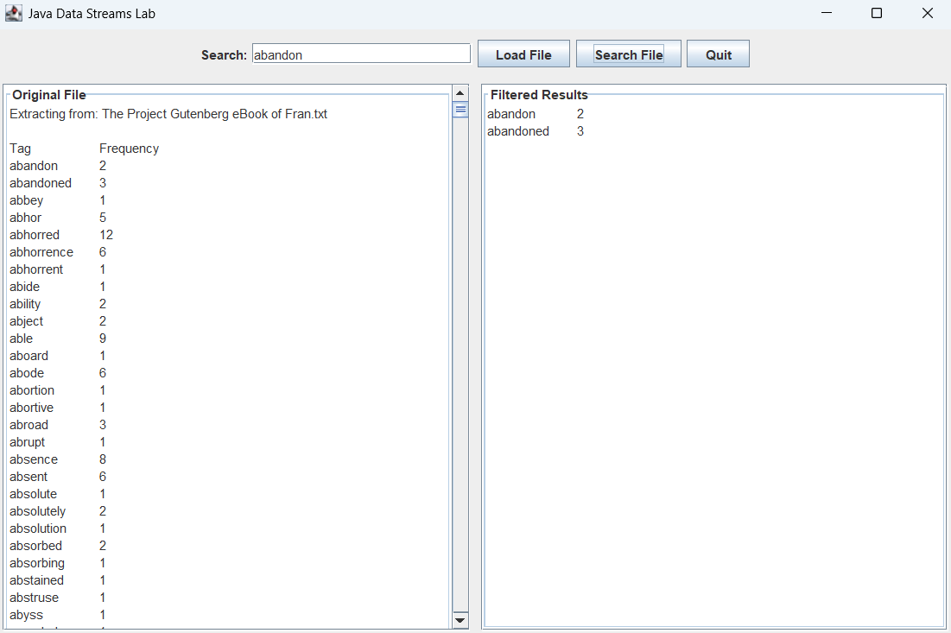
- Use 3 different search strings, that is a different one for each example.
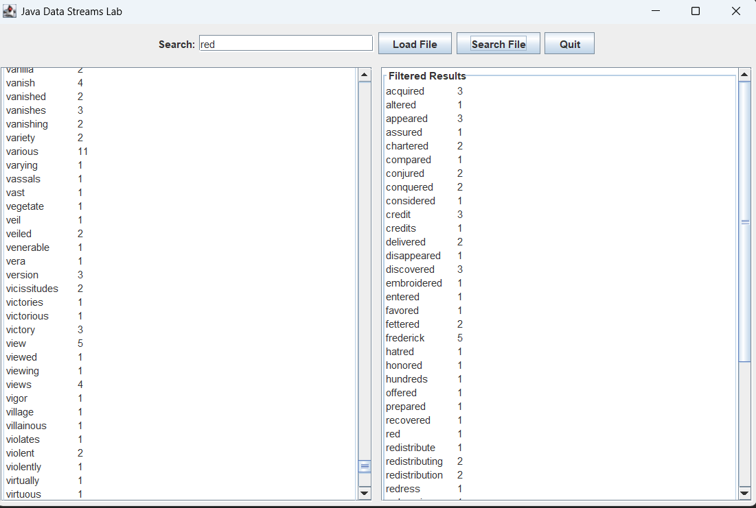
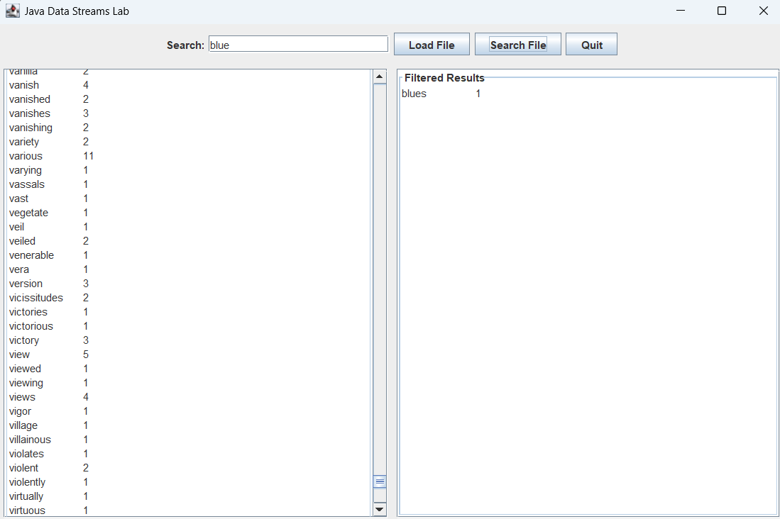
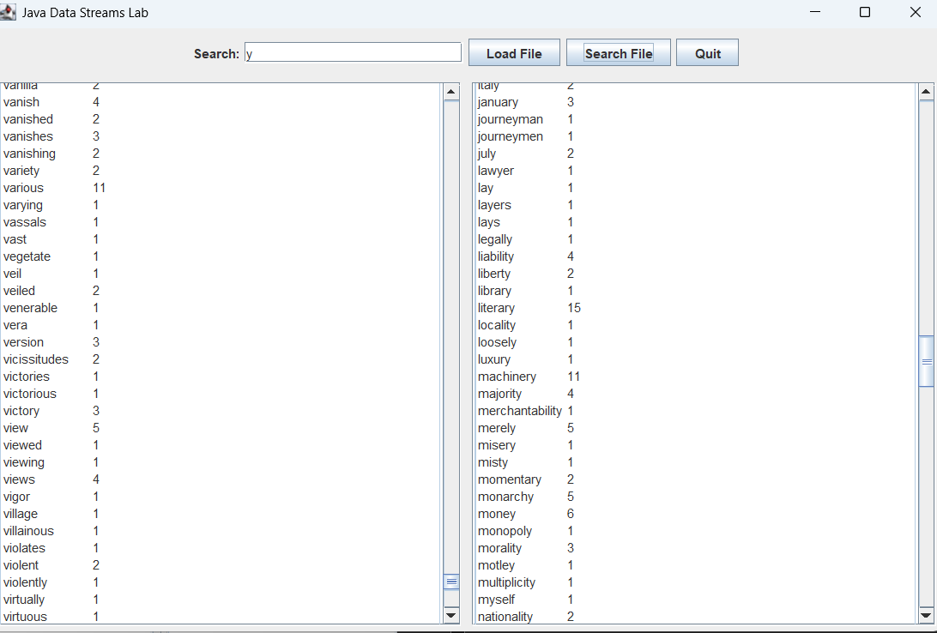

Submitting your Work:
Use the Canvas Assignment mechanism to submit the link to your GitHub repo for this project and after inserting your screen and code shots this file renamed LastnameFirstname _Lab_09.docx (using your actual name).

